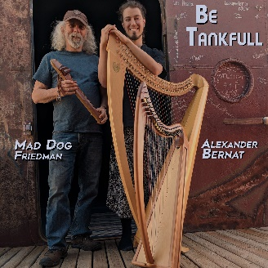 | Mad Dog Friedman & Alexander Bernat – Be Tankfull  Contact: Mad Dog Friedman  EMAIL: maddog@poetscoop.org  MOBILE: (970) 203-4757  WEBSITE: www.maddogharp.com

BOULDER, COLORADO, 6/21/2018 – This summer brings the release of the fifth full-length album from Mad Dog Friedman & Alexander Bernat. A CD release celebration is scheduled at Dazzle in downtown Denver on Tuesday, August 28, 2018, from 7 – 8:30 pm. (The $10 cover for this event may be applied to the new CD purchased directly from the artists at this event.)
Be Tankfull was recorded on May 15 & 16, 2018, in The Tank, a truly extraordinary sonic wonderland. As with Mad Dog Friedman and Alexander Bernat's four other collaborations, Be Tankfull, was created entirely of spontaneous compositions with healing intent, featuring Alexander Bernat on Celtic harp and Mad Dog Friedman on Native American flute. The vocals of Samantha Lightshade are also featured on three tracks along with her debut on Native American flute. Be Tankfull is eighteen extended improvisations on two CDs with over two hours of music full of the sonic magic of The Tank. It is truly a unique experience to make music in The Tank, one that can, in many ways, forever change how one interacts with music and sound. (Please see tanksounds.org to find out more about this Colorado treasure.)
The tracks on Be Tankfull were mixed live by Samantha Lightshade, whose kinesthetic understanding of this acoustical paradise is unsurpassed. Her intent was to recreate the experience of playing in The Tank in the recording. Staying true to this focus, no effects, compression, overdubbing or tone manipulation were used to master these raw mixes. The natural reverberation of The Tank is heard and felt the way the musicians did, as they and The Tank created this music together. The Tank demands total immersion and spontaneity, each musician must respond to the moment as well as the lingering presence of the past. The Tank slows and opens both the listener and the performer allowing beauty to emerge from where it lives inside each of us.

To listen to the digital pre-release please go to https://maddogfriedman.bandcamp.com/album/be-tankfull.
For more information, promo requests, or to arrange an interview, contact:
Mad Dog Friedman (maddog@poetscoop.org), (970-203-4757), (www.maddogharp.com).

